THE COURSE MASTER & TSDS REPORTING
Important Dates and Deadlines:
- Friday, September 29, 2023 – Class Roster Collection (Data entered by September 15, 2023)
- Friday, October 27, 202s3 – Fall PEIMS & ECDS (Data entered by October 20, 2023)
- Friday, February 23, 2024 – Class Roster Collection (Date entered by February 2, 2024)
- Friday, May 23, 2024 – Summer PEIMS (Data entered by May 17, 2024)
- August 2, 2024 – Extended Year/Summer School (Data entered by August 2, 2024. Additional time will be provided for Dual Credit, Session 2)
Class Roster Collection:
This collection includes organization, staff identification and demographics, class assignment, student identification and demographics, and class enrollment data.
PEIMS Collection:
This collection includes organization, staff identification and demographics, detailed staff class assignment, class assignment, student identification and demographics, class enrollment and course completion.
Course Master - WS\OF\CS\BC\CM\CM – Texas State Specific
*Service ID – Refers to the service supplied by staff and identifies course instructed to students. TWEDS C022.
Collection: Fall and Winter Class Roster, Fall, Summer and Extended Year PEIMS. Local Service IDs that begin with an 8XXXXXXX do not report a course completion record.
Transcript Area – Indicates transcript placement.
PE Waiver Course: Prints “W” in PE/Equivalent after selecting the appropriate Semester.
*Voc Ed Contact Hrs – Calculates CTE weighted funding.
Collection: Summer PEIMS
There are very specific requirements for a course to be eligible for CTE weighted funding. Campuses must communicate with the CTE department to determine whether a teacher is CTE certified and if the course section is entitled to receive weighted funding. (i.e. sped teacher, long-term subs, teacher). Notify PEIMS department if a section’s weighted funding is to be turned off.
Some examples of CTE course sections ineligible for funding: Electronic delivered courses, Homebound courses, ECHS courses, some TLC courses, some long-term substitutes are not eligible to receive contact hours
*College Credit Hrs – Indicates the number of college credit hours a student earned for the completion of a dual credit course
Collection: Summer and Extended Year PEIMS. If a course awards College Credit Hours after both halves of a course are completed the A portion of the course will have 0 and the B portion of the course will have the College Credit Hours entered. College Credit Hours should mirror the student’s college transcript.
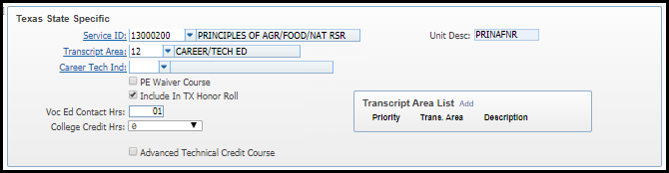
Subject: Groups courses into general areas for reporting purposes.
*Course Type: Indicates the type of course for transcript purposes and determines how a course is extracted for PEIMS purposes. D – College Dual Credit, R – Summer School. The course type code will determine if the course sequence code should report a leading “D”
Collection: Summer and Extended Year PEIMS.
Department: Allows courses to be grouped into departments for reporting purposes
*College Credit Hrs, Course Type, Course Sequence and Class Meet work together to create the Course Completion Record for Summer and Extended Year PEIMS.

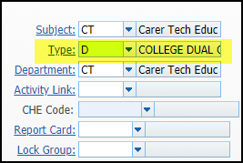
Course Master – Section -WS\OF\CS\BC\CM\CM – Texas State Specific
*Course Sequence – Identifies the unique part(s) of a course when a course is taught during a single grading period or semester or across multiple grading periods or semesters. Course sequence codes 0, 1, 2 are reported for high school course only. Course sequence code A are reported for Courses that do not receive high school credit for Grades EE-8.
The code for the first semester of a two-semester course is reported as a “1” no matter if the course is taken in the fall semester or the spring semester. The course sequence code identifies the order in which the course was scheduled in the class scheduling system.
Dual Credit Course Sequence are used for dual credit courses only. The length of the course for dual credit courses refers to the length of the college course, not the high school course. The “D” course sequence will generate through the Skyward extraction process based on the Course Type code “D” in the Course Master. If the Course Type code is not coded correctly, the dual credit course will not extract properly for PEIMS.
Collection: Fall (1-12) and Winter (EE-12) Class Rosters, Summer and Extended Year PEIMS (HS courses only).

High School Courses:
0-0 – Semester Only Classes. (Example: Government, Economics, Psychology, Accelerated Course).
1-0 – is also appropriate if the course is an accelerated course and the course will award a full credit in one semester.
1-1 – First half of a two-semester course (yearlong)
2-2 – Second half of a two-semester course (yearlong)
Dual Credit Examples:
Dual Credit, 1 college course, 1 college semester. Student completed and passed a dual credit Sociology course that is a one semester high school course and a one semester college course. Course Sequence Code D0
Dual Credit, 2 college courses 1 college semester each. Student completed and passed a dual credit English course that is a one high school course lasting 2 semesters and 2 college courses (one semester each) to earn 6 college credit hours. The college credit hours are reported at the end of each college course. Course Sequence Code D0 for both semesters.
Dual Credit, 1 college course over 2 college semesters. Student completed and passed a dual credit Chemistry course that is one high school course lasting 2 semesters and one college course taught over those 2 semesters. Student earned 4 college credit hours. The college credit hours are reported at the end of the college course (the end of the 2nd semester). Course Sequence Code D1 – semester 1 and Course Sequence Code D2 – semester 2
NOTE: CCMR Requirements – According to CCMR Requirements Document 2021-2022 D0, D2, D4 or D9 are acceptable for College Ready Indicators. D1, D3, D5, D6, D7, D8 are not acceptable course sequences for College Ready Indicators even if College Credit Hours are reported.
*Non-High School Course – Check the box for all non-high school course classes to generate Course Sequence code A
Collection: Fall (1-12) and Winter (EE-12) Class Rosters All Elementary and Middle School classes that do not award high school credit will have a check marked in the box.

*Exclude record from PEIMS - This box is selected on a situational basis. By selecting this option, the section will be skipped and not reported to PEIMS.
Examples:
Sections used for rostering to a third-party vendor such as ELA Aware and Non-Membership course sections
If the campus reports one staff responsibility record for PK teachers, the remaining sections are not required to be reported to PEIMS.
If the campus reports one staff responsibility record for KG teachers, the core sections are not required to be reported to PEIMS. However, since specials (PE, Art and Music) are instructed by another teacher these sections must be included in the collection.

*TSDS Homeroom: Check the box for PK and KG Homerooms only
Collections: ECDS PK & KG Homeroom sections will select this option.
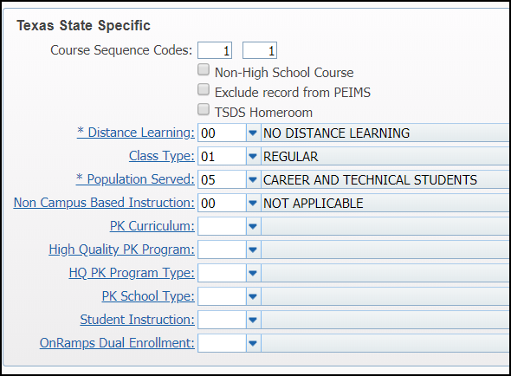
*Class Type: Identifies the type of class providing instruction to students in particular class settings
01 – Regular
02 – Non-Regular (ISS, DAEP, Televised Instruction, Non-DAEP, Sped, Residential Care and Treatment Facility)
Collection: Fall and Extended Year PEIMS

*Population Served: identifies the student population for which a service has been designed or is intended. It does not necessarily identify the program eligibility of the students who receive the service. What population is the service designed, not by the student population. If two or more populations are being served, only one record is selected, using the population for which the service was designed (intent).
Collections: Fall and Extended Year PEIMS.

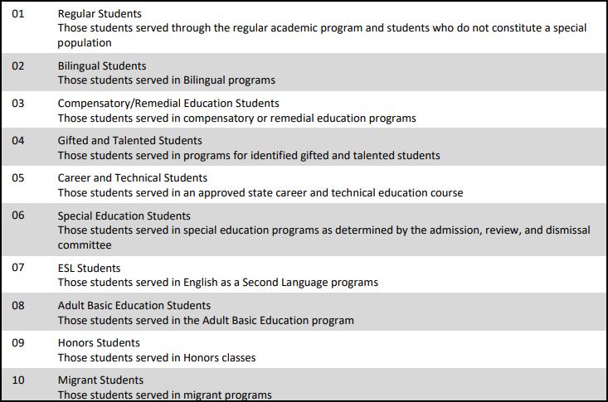
*Non Campus Based Instruction: Indicates that a course was offered for class credit or student achievement, but was not taught by a school district employee or a contracted teacher or was taught by a school district employee or contracted teacher at a facility other than the campus where the student is enrolled.
Collection: Fall and Winter Class Rosters and Summer PEIMS
00 = A teacher will be required to report with a course section.
10 = High school courses only
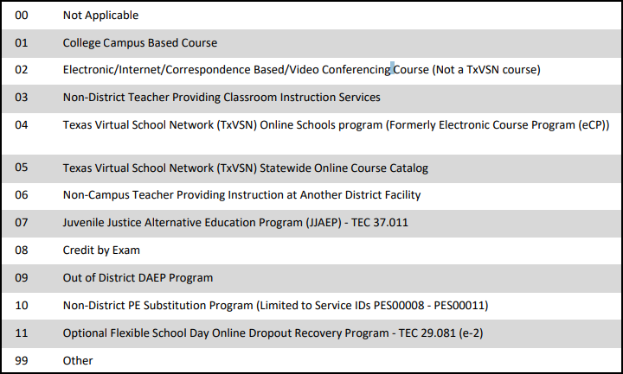
*PK Curriculum: Indicates curricula used in the district’s prekindergarten program serving eligible four-year-old students
Collection: PK ECDS:
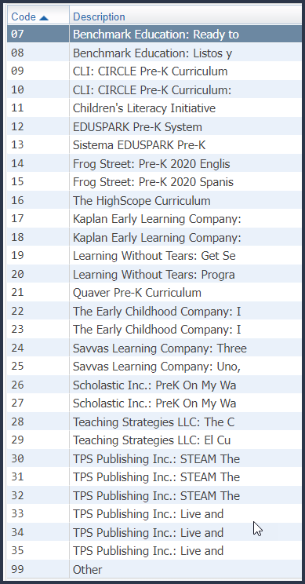

*High Quality PK Program: Indicates curricula used in the district’s prekindergarten program serving eligible four-year-old students. For the 2023-24 school year NCISD uses #26 Scholastic
Collection: PK ECDS
0 – Does not offer high quality PK program
1 – Participates in a high-quality PK program
*High Quality Program Evaluation Type: Indicates the type of program evaluation tool LEAs use to report the progress of students participating in a High-Quality PK program.
Collection: PK ECDS
00 – No
01 – TEA Self-Assessment Tool
99 - Other
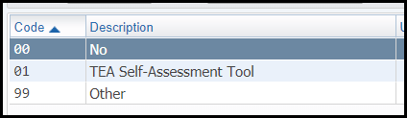

*PK School Type: Indicates the type of prekindergarten program that is offered
Collection: PK ECDS
02 – Public Pre-K

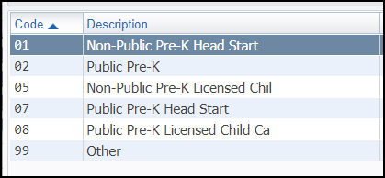

*Student Instruction: Indicates the PK student type of instruction
Collection: PK ECDS
01 – Full Day
02 – Half Day - Morning
03 – Half Day - Afternoon
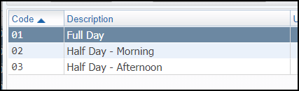

Course Master – Section -Meet WS\OF\CS\BC\CM\CM – Texas State Specific
NOTE: A Meet is required to be created for EVERY course and section that NCISD awards high school credit regardless of the delivery (i.e. electronic, dual credit, credit by exam). It is not necessary to build out a Meet for transfer courses. Not appropriately building out a Meet will not create a Course Completion record for the students taking the course and thus underreporting courses offered at NCISD and in turn could impact accountability ratings.
*Teacher: Indicates the teacher(s) of records for a course section
Collection: Fall and Winter Class Roster, Fall Summer and Extended Year PEIMS. Enter the teacher according to teacher’s assignment begin date. If the position becomes vacant then it is appropriate to enter the name of the substitute teacher who is instructing the class during the vacancy.
Note: All teacher’s of records on Snapshot dates should be included. Teacher Incentive Allotment is based on teacher of record in the Winter Class Roster Collection.

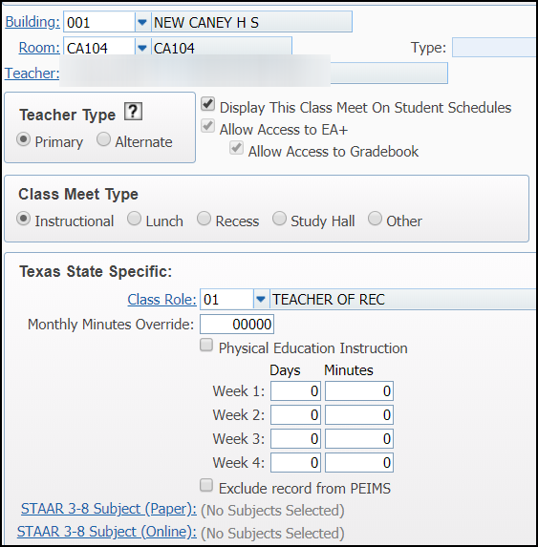

*Classroom Position: Identifies the type of teacher or PK Educational Aide
Collection: PK and KG ECDS, Fall and Winter Class Roster, Summer and Extended Year PEIMS
01 – Teacher of Record
02 – Assistant Teacher
03 – Support Teacher
04 – PK Classroom Aide
Assistant and/or Support Teacher are reported to PEIMS if they provide instruction.
*Monthly Minutes Override: Is the total number of minutes devoted to a particular service in a standard month. A standard month is considered to be the four weeks in October including the PEIMS Fall snapshot date.
Collection: Fall PEIMS. Enter the monthly minutes if the Bell Schedule is not being used to generate minutes. (Elementary Only)
*Physical Education Instruction: Indicates for a physical education teaching staff responsibility, the number of minutes in which physical education instruction is provided for each course section by campus during the 4 weeks in October that include the last Friday in October. If more than one staff member is serving a group of students during a physical education class period, the person who is the “teacher of record” should be reported. Any other staff members should not report a value.

Collection: Fall PEIMS. Select this box for the following SIDs and only for the Teacher of Record:

“02530002," "02530003," "02530004,” “02530005,” “02530006,” “02530007,” “02530008,” 02850000," "03823000," "PES00051,” "PES00053," “PES00056," "82210XXX," "82931XXX," "82310XXX,” or "84200XXX"
*Week 1-4, Days, Minutes: Collected in Fall
For the month of October enter the number of days the section attends PE and the number of minutes the section is instructed. In the sample below the PE section meets twice a week for a total of 110 minutes each week. If the number of students in the class is blank, then 0 minutes should be reported for Physical Education Instruction Minutes.
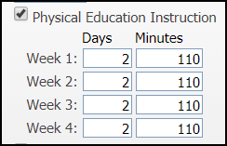
Exclude Record from PEIMS: This box is selected on a situational basis.
Example:
Section meet is created because the Teacher of Record is out on FMLA and the department lead was overseeing the Teacher of Record’s grade book.
Section meet is created at the elementary level for Homeroom teachers to monitor student progress.
Miscellaneous Student Scheduling and Reminders
SAO students and Walk-in speech students must be scheduled into 10000X – Non-Membership Course. This will assist the campus with tracking student’s progress, enrollment and ensure the student is reported to PEIMS correctly and counted on Membership Reconciliation Day.
Who takes Attendance?
- The teacher that is serving the student(s) at the ADA time (Official Attendance Accounting Time)
- Are students in Specials during ADA? If Yes, the Specials teachers should be scheduled to the student and will be responsible to take daily attendance.
- Are students in Resources during ADA? If Yes, the Resource teacher should be documenting this through Office Log. A schedule change may not always be appropriate.
It is not appropriate to have a Homeroom Teacher take attendance at ADA time if the students are NOT being served by the Homeroom Teacher at that specific point in time.
I have a Special Ed Student. Who is the Teacher of Record?
- It Depends. What does the Student's Schedule of Services say?
- This information is provided by the diagnostician, case manager or campus administrator. The PEIMS department does not determine who should be reported as the Teacher of Record.

At the very minimum Run the Course Report by Section to verify PEIMS data elements are correct.
WS\OF\CS\BC\RE\BS
